CSE 4508 – RDBMS Programming Lab

Lab 7

Prerequisites: Oracle 10g Express Edition, Notepad

Instructor: Sadaf MD Halim

**A**. Write a block of PL/SQL code which checks whether the current year is a leap year and prints “Yes” or “No”. After this, it should print the immediate previous leap year, and the immediate next one. [Do NOT simply hardcode and print 2016 and 2020]

**B**. Write a PL/SQL function called **times_table** which takes two inputs: **n**, which indicates how many times tables you have to print, and **iter** which indicates how far along the times table you have to go. Then write a block of code to call this function, taking inputs of n and iter from the user. The example output for **n=2** and **iter=10** is shown:

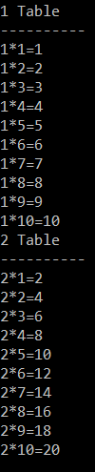

**C.** A hacker stumbles onto a database table containing only two columns: Username (varchar2) and Password_Length (number). Password_Length only contains a number, such as 7 or 8, denoting how long the password of that username is. Write a block of PL/SQL, using a function if necessary, which will first find the highest Password_Length from the table. It will then find out how many permutations the hacker needs to go through to crack that password. (The password only contains letters of the alphabet. You therefore have 26x2= 52 possibilities for each symbol of the password. However, no character can be repeated. So the correct answer, for a password of length 4, is: 52x51x50x49 = 6497400)